caBIG® Semantic Infrastructure

Concept of Operations

For Internal Use Only

CONFIDENTIAL

Version Number | Date | Description
0.1 | 02/02/2009 | Initial Draft Based on DSR Con Op (Dec2008).
0.2 | 3/19/2009 | Draft for Internal Team Review.
0.3 | 04/07/2009 | Draft for Management Comment, Chicago Meeting.
0.4 | 06/12/2009 | ECCF Addenda Added
0.5 | 06/19/2009 | Compositional/Derivative Pilot Added
0.6a, b | 06/24/2009 | a) Government only version (budget projections) , b) sanitized
0.7 | 06/26/2009 | Revised Fig 3, table and text in Addenda, mod of Initiative 1

Version Number | Date | Contributor/Editor
0.1 | 02/02/2009 | Frank Hartel
0.2 | 3/19/2009 | Dave Hau, Margaret Haber, Sherri de Coronado, Larry Wright
0.3 | 04/07/2009 | Frank Hartel
0.4 | 06/12/2009 | John Kiosch
0.5 | 06/19/2009 | Jobst Landgrebe, Alan Honey, Charlie Mead, Frank Hartel
0.6a, b | 06/24/2009 | Frank Hartel
0.7 | 06/26/2009 | Paul Boyes, John Koisch, Brian Davis
I. Vision 5
II. Background 6
III. Mission 7
IV. Objectives 8
V. caBIG® Semantic Infrastructure Overview 9
VI. Stakeholders 21
VII. Alternatives/Constraints/Contracting Approach 22

Vision
NCI’s vision is to reduce the burden of cancer on patients and the nation. The caBIG® mission is to support this vision by creating a virtual web of interconnected data, analytical resources, individuals, and organizations that redefines how research is conducted, care is provided, and patients/participants interact with the biomedical research enterprise. This mission is informed by and supportive of the broader DHHS effort to build a comprehensive health IT infrastructure that supports personalized medicine and integrated care.
The vision of the caBIG® infrastructure is to:
- Connect the cancer and broader medical and research community through shareable, interoperable “network of networks”.
- Support the business/transaction/message based dynamic semantics that will underlie the emerging information infrastructure supporting healthcare delivery
- Deploy and extend standards and a common syntax and semantics to more easily share information.
- Build and adapt tools for collecting, analyzing, integrating and disseminating information.
- Enable cancer centers and vendors to leverage this infrastructure to provide support of the broader community.
The Semantic Infrastructure and Operations Group composes the semantic aspects of the CORE Program Area, the caBIG® Vocabulary and Common Data Elements Workspace, and certain aspects of the caBIG® Architecture Workspace, and caGrid®.

Management personnel for caBIG® Semantic Infrastructure and Operations includes:
- Product Management
  - Director for Semantic Infrastructure and Operations (Francis Hartel)
  - Director for Enterprise Vocabulary Services (Francis Hartel (acting))
  - Associate Director for Products and Programs, Core Infrastructure and caDSR (Denise Warzel)
- Content Management
  - Associate Director for Enterprise Vocabulary Services (Margaret Haber, Lawrence Wright)
  - Senior Biomedical Informatics Specialist (Sherri de Coronado, Gilberto Fragoso)
  - Associate Director for Biomedical Data Standards (Dianne Reeves)
- Engineering Management
  - Director for Core Infrastructure Engineering (Avinash Shanbhag)
  - Associate Director for Semantic Infrastructure Engineering (David Hau)
  - Associate Director for CORE Infrastructure Engineering (Sichen Liu)
  - Senior Biomedical Informatics Specialist (Gilberto Fragoso)

The activities of the NCI CBIIT Semantics and Operations Group fall into three areas:

- Content Management - the processes and procedures that ensure the breadth and quality of the metadata and terminology used to record the semantics of data meet the needs of the caBIG® community.
- Semantics Infrastructure – design and development of software resources and operations including producing reference implementations of platform independent models
- Semantics Architecture and Management – defining the platform independent (as also called “implementation Independent”) specification for systems and processes required to meet the semantics needs of the CBIIT/caBIG enterprise, and for assuring that operational requirements for semantics support are met in a timely and reliable way.
Our vision is to provide computational and human interpretable representation of the meaning and context of data and transactions. Realization of this goal is a vital to enable the caBIG® community to revolutionize biomedical research, personalized medicine, and integrated care. To achieve this vision, the semantic infrastructure must:
- Continue to provide caBIG with computationally tractable representations of the meaning and representation of data, and to extend semantic support to analytic and other services so that they can be discovered, understood, and securely utilized.
- Utilize a consistent, comprehensive information management discipline such as ECCF’s RM-ODP to define both enterprise semantics needs and implementation neutral solutions to meet those needs.
- Provide reference implementations of enterprise-level platform independent models addressing semantic needs, especially the need for behavioral semantics.
- Reduce the level of effort associated with creation of semantic information, in part by leveraging to the greatest extent possible automated approaches to harvest semantics information from line of business activities

Background

The cancer Biomedical Informatics Grid (caBIG®) initiative, overseen by the National Institute of Health’s (NIH) National Cancer Institute (NCI) Center for Biomedical Informatics and Information Technology (CBIIT), was conceived to connect the cancer research and clinical community through open, interoperable technology that facilitates data sharing and collaboration, speeding the translation of discoveries from research to clinical care. Since its inception, caBIG® has launched innovative tools, infrastructure and policy resources that enable individuals and organizations in the cancer community and beyond to move further down the path to realizing personalized medicine and integrated care. Over 1,000 individuals from more than 190 organizations are currently participating.

The semantic model and infrastructure forms a key component of the caBIG® collaborative infrastructure, which enables eliciting, capturing, advertising, and discovering the integration semantics for interoperable components that may be leveraged to build applications and ultimately to meet user requirements. The current semantic infrastructure uses the ISO 11179v3 standard as its central component in allowing data elements and models to be annotated with concepts, and curated and registered in a repository allowing lookup and retrieval by both end-users and applications. It enables the automatic integration of data for sharing and collaboration by provisioning the infrastructure with clear, computable, and unambiguous data descriptors for those who would create software that can use and interpret the data in the service of cancer research.

There are two issues with this broad approach:

- Creation and curation of the needed data semantics descriptors for seamless integration of data via caGrid can be demanding, and may ultimately limit the growth and adoption of this aspect of caBIG.

That is, achieving economies of scale via the semantic infrastructure is desirable but very difficult, especially from the standpoint of defining information elements, capturing the essential semantics, and then advertising these captured semantics for reuse. And of course, these information components must be contextualized within one or more behavioral models that express the means by which information is both exposed and the means by which it is analyzed. Thus, the caBIG semantic model covering exchanging research information must be capable of expressing and using computationally tractable representations of the interactions among participants engaged in health care and research. Historically, these have been realized within caBIG through the use of compatibility guidelines that defined a leveled approach to promoting optimal exchanging of research information. The refinement of these compatibility guidelines is still underway, but that effort itself has proved difficult. The reasons for this difficulty illuminate the second issue.

- The same semantic model that has proved remarkably successful in optimizing data exchange in support of cancer research does not automatically provide a similar optimization in other spheres. Thus, the ECCF defined “Cancer Research Data Exchange” as a sphere unto itself, with its own set of optimization paths, but without necessarily being applicable to other spheres (or what the ECCF calls topics). It makes sense to expose objects that represent research domain concepts via web services, and to allow interactions that support their direct query. This model (querying semantically precise object graphs without regard for location or persistence type) is adequate in a high-trust environment where workflow and business rules may be imposed after the results of a query are returned (if at all). This same model, however, cannot successfully be optimized to fit other topics. Thus, an effort to curate information elements to fit all needs results in a stalemate for the enterprise and the curator.

It is critical that the caBIG semantic model and infrastructure evolve to minimize the effort required from data owners and service providers to advertise comprehensive semantics for their data, services, and syntactic infrastructures, promoting reuse and durability. However, it is also clear that across the broad scope of the NCI, this evolution cannot happen along a single path – it should happen on a topic by topic basis, with optimizations learned from the experience of implementation and design.

In summary, the behavioral semantics as well as static semantics (that has here-to-fore been the focus of caBIG semantics) must be elicited, captured, stored, and advertised as appropriate, contextualized by topics. In many cases, these topics represent durable components in their own right, and may thus become durable enterprise services that may embody policies or business rules.

Mission
The Semantic Infrastructure project is an enabling project. It does not produce health data or business processes, but produces infrastructure for eliciting and capturing static and dynamic semantics, standards compliant terminology and metadata resources, ontology enabled Grid and Web resources, and semantically aware services such as natural language tools for the lab and clinic. Its orientation and initiatives will be aligned to support the NCI enterprise vision.
NCI has made personalized medicine and translational research priorities. These are interrelated: each requires that researchers, clinicians, industry, and government agencies share information quickly, accurately and in ways that will accelerate the ability to discover, test and release new modalities for detection and treatment and improve care. These capabilities must be effectively integrated with broader health IT systems, and are also requirements that any national health network would need to possess. Therefore the CBIIT/caBIG semantic infrastructure must be designed to scale to national and international implementation and integration, as well as support interoperability from a technology neutral approach.
The mission of the NCI CBIIT Semantics and Operations Group is to accomplish five specific tasks. These are to:
- Develop or adopt abstract general models or frameworks for specifying how standard terminologies, ontologies, message specifications, data elements, rules and other semantics building blocks can be leveraged to provide a shareable, interoperable electronic infrastructure to connect the biomedical research and care delivery communities;
- Develop or extend domain specific models, including standard rules and a common semantic style of representation to more easily develop applications that can share information;
- Employ the Enterprise Compliance and Conformance Framework to represent frameworks and models in an implementation independent manner
- Build and adapt tools and interfaces for generation, curation, storage and use of semantic information, and for convenient lookup, retrieval and transformation of this information by both end-users and applications;
- Supply semantic content – terminology, ontology and metadata – to the infrastructure forming a basis for ongoing usage and expansion of the caBIG® data sharing and semantic discovery infrastructure, as well as directly to end users of these resources and infrastructure; and
- Work with the caBIG Knowledge Centers and other community based resources to provide training and support to the community in terms of evaluating or using NCI-based semantics resources as well as federated community-based resources as they become available.

Objectives

The major goal of the NCI CBIIT Semantics and Operations Group is to enable semantic interoperability in a virtual network or cloud of interconnected organizations, which in turn redefines how research is conducted, care is provided, and patients/participants interact with the biomedical research and care enterprise. The research community is primarily focused on the development of new knowledge and treatments, while the health care community is focused on clinical care and outcomes; both objectives can be advanced by leveraging the semantic infrastructure investment in CBIIT and caBIG® tools and frameworks.

Due to the fundamental differences of the research and clinical domains they may employ different architectural models (compositional versus derivative for example). The semantic model and infrastructure must support each domain, uniting them semantically. The objectives noted below stem from the desired outcomes of the stakeholders in the NCI, CBIIT and the caBIG® program, both nationally and internationally.

The objectives of the initiative are to identify and evaluate alternative approaches to establish and use semantics, to formally model promising approaches, and to develop reference implementations and operational resources and services to support semantic and syntactic interoperability in biomedical research and healthcare IT systems and information services.

Scientific Goals
The scientific goals of the initiative are to:

- Improve practical utility of semantics to support translational research and personalized medicine

Programmatic Goals
The programmatic objectives of the initiative are to:

- Develop implementation independent architecture model(s) which define the semantics backbone components and behavior
  - Architect semantics backbone to support and unite:
    - Domains using different architectural types (e.g. compositional vs derivative)
    - Domains with different business imperatives (regulatory compliance vs. rapid evolution)
  - Design/deploy backbone to:
    - Reduce overhead associated with creation and maintenance of semantics information
    - Provide semantic integration across .NET, Semantic Web as well as CORBA-bases Grids
- Participate in the development of national and international semantic interoperability standards to protect caBIG®'s investments in semantic framework, and to meet evolving requirements of caBIG® and the broader biomedical and health community.
- Deploy within caBIG reference implementations of the semantics backbone components to:
  - Demonstrate their practicality
  - Increase the semantic coherence within caBIG
- Follow caBIG dictates for all software development:
  - Allow users to decide on their choice of open or COTS technology platform
  - Maintain an open-source environment
  - Follow rigorous engineering methodology, including automated build/deployment and continuous integration
- Develop, adopt, utilize and promote best practices and methodologies for modeling developing, operating and distributing metadata, terminologies, ontologies and other data semantics artifacts.
- Create and distribute open, free semantic content that supports strong shared semantics and is directly useful to builders and users of health IT systems and biomedical researchers.

caBIG® Semantic Infrastructure Overview

The caBIG® consortium is a partnership of government, academic, and industry stakeholders in health care, both nationally and internationally. Due to the successes of the caBIG program, the stakeholder community has broadened to include BIGHealth and the NHIN, as well as the familiar communities involved in fighting cancer. These researchers, providers, patients, advocates, payers, product innovators, investors, and information technologists have come together in a novel organizational framework to make real the new paradigm of personalized medicine and integrated care.

Role of the Enterprise Conformance and Compliance Framework

The fundamental challenge is providing the community with an interoperability framework that surfaces and clarifies the inherent complexity of the domain while allowing the communities to continue to effectively respond to the changing needs of science and healthcare. NCI CBIIT has adopted Reference Model for Open Distributed Processing (RM-ODP ISO/IEC 10746) and developed the Enterprise Conformance and Compliance Framework (ECCF) for use with all major caBIG®/caGrid® projects. RM-ODP provides for distribution, interworking, platform and technology independence, and portability. It provides the basis of the ECCF, an enterprise architecture and interoperability framework comprising formal conformance and governance models. ECCF artifacts focuses on the enterprise, information, and computation points of view as defined by RM-ODP provide the required degree of implementation independent abstraction while also providing the precision needed for interoperability of independent implementations.

The ECCF will be used to govern all major NCI CBIIT Semantics Initiatives.

The ECCF provides an approach to providing implementation-neutral system specifications that can be accessed for compliance at any given level of specification conformance to interoperability criteria. The RM-ODP artifacts from the enterprise, information, and computation points of view provide an implementation independent logical design for third parties to use to develop their own implementations, and for caBIG/CBIIT developers to use to develop reference implementations, while the ECCF provides for conformance and compliance assessment.

The Architectural Infrastructure is the means by which CBIIT enables and delivers architecture and interoperability within the framework provided by the RM-ODP and ECCF. It insures that the integrity of the domain semantics delineated by the RM-ODP viewpoints is preserved from definition to deployment by way of contracts. Figure 1 shows the essential relationship between these three infrastructure views.

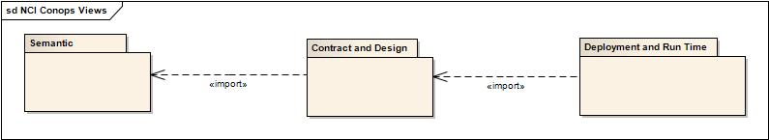
Figure 1: The Architectural Infrastructure Views Supporting the NCI Semantics Development. See Figures 2 through 5 below for the components of each viewpoint package.

The Semantic Infrastructure View

The Semantic Infrastructure comprises the means of capturing integration semantics for systems based on four RM-ODP viewpoints. The essential problem space is diagrammed in the model below.

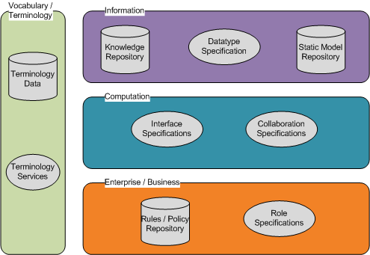
Figure 2: Logical Components of the Semantic Infrastructure View. Repositories and services expose semantic components. Note that this logical representation may or may not be realized physically.

Information Semantics comprise metadata and static models that can be used to create and enable designs and solutions. These are housed in a metadata repository and a static model repository. Models are not necessarily wire-format representations – domain analysis models, for example, may be kept here as well.

Computation and Engineering Semantics comprise interface specifications, collaboration specifications, and engineering specifications that can be used to create or enable designs and solutions. Interfaces represent abstractions of behavior that systems may take on. Collaborations represent patterns of behavior between and among interfaces designed to fulfill some business need. Engineering specifications comprise platform specifications and the means to realize interface and collaboration specifications.

Enterprise and Business Semantics include a rules and policy repository and role specifications. Rules and policies may or may not be expressed in formalism, but this repository houses the regulations and compliant procedures required to support the mission of CBIIT. It includes permissions, obligations, and prohibitions associated with certain objects in the domain, as well as potentially establishing which objects can play which roles. It is intended to act in concert with the rules associated with information and computational semantics, although it is a matter of management how and to what degree these would overlap. Role specifications include analysis supporting the capacities, competencies, and capabilities associated with coherent patterns of behavior that a system might play.

Each of these semantic groupings might require or be enhanced by a terminology associated with their domain. These terminologies may be implementation focused (for example, Snomed) or may be structural (for example, typing model components).

NCI CBIIT has certain of these components in place already, though the composition should be evaluated to establish fitness for purpose (see initiatives below).

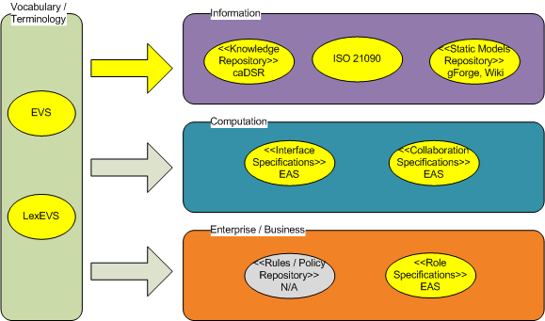
Figure 3: Current implementations providing coverage for various semantic components. Yellow indicates complete or partial coverage. Stereotypes represent mapping to intended infrastructure (See above)

The Contract Design Infrastructure View

The Contract Design Infrastructure (see Figure 1) comprises the means of capturing the logical components of a contract. Currently these logical components are captured implicitly in code and in the design of applications. Certainly some fully specified contracts deserve to be captured, preserved, and reused where possible. However, capturing other contract components (and optionally realizing them) should be in scope for an enterprise such as CBIIT given its mission. An example of capturing contract components and realizing them is the implementation of a durable service that is specified sufficiently to allow clients consume them at run time without an early explicit binding. Other examples are discussed below.

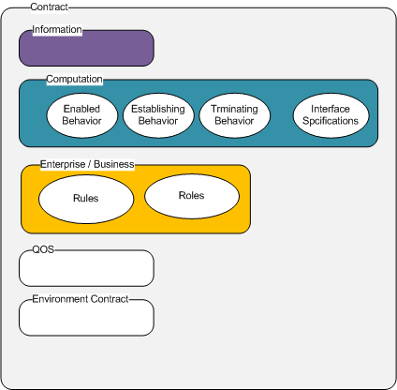
Figure 4: Contracts bring together information, computational, and Enterprise elements, and express quality of service and environmental requirements

A contract is an agreement governing all or part of the collective behavior of a set of systems. A contract specifies the permissions, obligations, and prohibitions for the systems involved.

Rules describe the permissions, obligations, and prohibitions of the roles involved in the contract.

Roles are identifiers for capabilities, capacities, or competencies that are enlisted to fulfill the terms of a contract.

Information components are represented by the static models and characteristics of static models that facilitate the behaviors as constrained by the permissions, obligations, and prohibitions established by the rules associated with the roles.

Contracts have an establishing behavior, a terminating behavior, and a behavior that is enabled by the contract being established. As well, they defined the interfaces that are bound to each role to support the permissions and obligations associated with that role.

An Environmental Contract is a contract between a system and its environment. It can describe both constraints on a systems behavior in the correct environment as well as requirements placed on a system’s environment for the system’s correct behavior.

Deployment and Run Time View

The Deployment and Run Time View (see Figure 1) comprises implementable specifications (which represent the key semantics), a configuration of enabling systems and contracts, and a run time view of systems interacting with each other to fulfill their contracts. Artifacts from this view are used in the ECCF to assess compliance. Each implementation of a service is expected to state it’s level of conformance with the implementation independent specification of that service as expressed as RM/ODP enterprise/information/computation artifacts. The closer the asserted level of conformance the higher the degree of semantic interoperability should be. Implementation viewpoint artifacts and functionalities are critical to empirically verifying that the expected level of interoperability has been achieved.

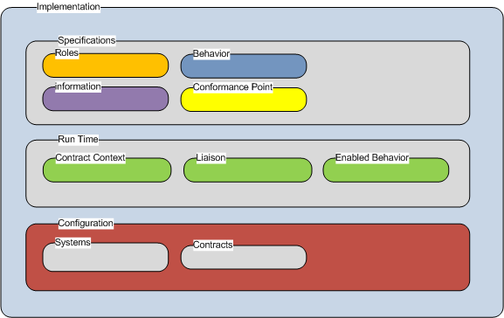
Figure 5: The Deployment and Run Time view. This is a static view of the components involved.

The Implementation is the instantiation of the configuration of systems with a particular objective whose validity is subject to verification.

Specifications are implementable collections of rules about systems and their interactions. They require a set of conformance points to be defined so that the semantics with which they are built may be verified. Semantic components include information, behaviors, and roles.

The configuration of an implementation consists of a collection of systems able to interact at interfaces as governed by contracts. A configuration of systems is designed to meet a specific objective, designated in the contract.

Run time is characterized by contracts being realized as liaisons between systems, resulting in sets of enabled behaviors. Contractual context is the knowledge that a particular contract is in place and that a particular behavior is required. Run time is demonstrated in the following behavioral model.

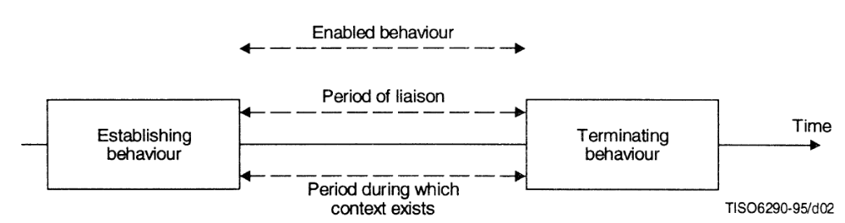
Figure 2: A time graph representing the states of a contract. A contract may be instantiated multiple times with different liaisons.

Existing caBIG Semantics Implementation

Today’s caBIG® Semantic Infrastructure forms the basis of the semantic interoperability capabilities embodied in the implementation of Data Services on the caGrid. This is shown below.

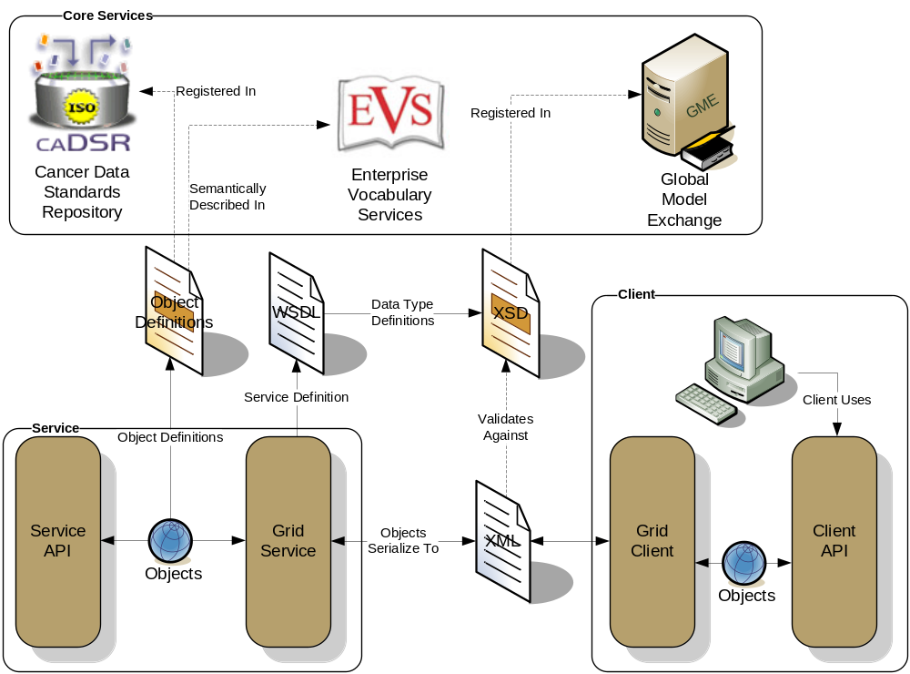
Figure 3: The caBIG® Semantic Infrastructure (caDSR and EVS) provides the basis for semantic and syntactic interoperability between clients and services on the caGrid.

The existing caBIG semantics implementation does not embody various properties of the three viewpoints shown in Figures 2, 4 and 5 as explained in terms of the architectural infrastructure above. Specifically:

- The role played by each system is implicit. In a services paradigm, this is sufficient for the client, but not for the service implementation. The role should be characterized by permissions, obligations, and prohibitions that are made manifest and have a durability of their own.
- The data service is (in the parlance noted above) the interface bound to this implicit role. This service has a single operation: Query. This system has an environmental contract (implicit) that dictates the terms by which it may interact with other systems, and since the data service is intended for use with any information type, it does not inherit rules associated with that information.
- However, the information that is bound through to the service implementation is built from an analytical process. That means that when these processes expose business rules associated with this information, those rules are modeled with the information. By decoupling the information from the interface, these rules do not form part of the environmental contract between the service implementation and its environment (its clients). Finally, since the Role played by the Data Service is implicit, the permissions, obligations, and prohibitions associated with this role will not be reflected in the Environmental Contract either. This results in a two-fold loss – the loss of the object’s business rules at the interface, and the potential for the misapplication of the implicit role to various information objects.
- The contract between all of these distributed components is implicit in the architecture, but explicit in the code of the systems involved. The contract of the whole system is durable and extensible, in that additional systems may take on the implicit role associated with the data service so that its objects are bound to that interface. When the contract is extended, it implies a reconfiguration of the implementation (additional entries in the index service, for example).
- The establishing behavior of this contract is issuing a request to the index service for an end point reference. The enabled behavior is the fulfillment of the query. The liaison is between the client (initiator of the query) and the system playing the role that is bound to the data service that was identified by the index service (the responder to the query). The contractual context exists for the period of the enabled behavior.
- The compatibility guidelines serve to insure that the enabled behavior can be performed and, separately, that the objects exposed are sufficiently annotated semantically. However, since these semantics are at least partially derived from rules about the information, there is a disjoin between the information available through a general query interface and the usage for which certain information was intended. Note that the enabled behavior of the overall contract is constrained by the enabled behavior of the environmental contract that characterizes each system exposing the data service interface.
- The implementation’s objective is characterized by the obligations associated with the (implicit) role that is bound to the data service and the permissions assigned to each role in the implementation. There are only two roles in the implementation – that of the client and that of the role that is bound to the data service.

The disjoin between the specified role, the interface, the information objects, and the environmental contract of the deployed service implementations seems not to be a problem in areas of high trust where business rules are not associated with information objects or where their application is unimportant. This is true in many of the research applications. Where this same pattern is intended to apply to more business oriented implementations (clinical data), this pattern is difficult to implement because of the disjoin between the rules and the exposed information. In other words, when a developer wants to simply expose data through a Data Service, this pattern is sufficient and powerful, but when it is intended to be repurposed for other uses, problems may arise.

caBIG already provides a vast framework for tools, tooling, and other pieces of infrastructure. Using the architectural infrastructure noted above, the existing caCORE tools and some of the caGrid
infrastructure may be categorized by the component of the new Semantic Infrastructure to which they relate. Re-use and adaption of the existing semantics is preferred over replacement whenever that is the cost effective solution to semantic requirements.

Below is an initial list (perhaps partial) of existing tools categorized by the project/package in which they are currently developed and managed. This list will serve as a starting point for the comprehensive mapping to the architectural infrastructure noted above. While these tools may only partially meet the functionality of the proposed architecture infrastructure, the rationale for using, adapting or replacing them will be contained in the project documents generated for each of the initiatives proposed by this Concept of Operations.

Table 1: Initial Allocation of Existing Tool Packages to Components of the new Semantic Infrastructure

Packages | Component
caAdapter
 | Mapping Tool
 | Core Engine
caDSR
 | UML Loader
 | CDE Browser
 | Admin Tool
 | Curation Tool
 | Formbuilder
 | Sentinel Tool
 | Freestyle API
 | caDSR Services
 | Bulk Loader
 | Semantic Integration Workbench
 | UML Model Browser
 | Object Cart
 | Domain Class Browser
caGrid
 | Global Model Exchange (GME)
 | Index Service
 | Metadata Model Service
 | Grid Trust Service
 | Grid Grouper
 | Dorian
 | Credential Delegation Service
 | Authentication Service
 | Federated Query Processor
 | Taverna Workflow
 | BPEL Workflow
 | Introduce
 | Data Services
 | Web Singal Sign On (Web SSO)
 | Transfer Service
CDE Browser
CDE Curation Tool
Common Security Module
Enterprise Vocabulary Service
 | LexEVS
 | Bioportal
 | NCI Terminology Browser
 | NCI Report Writer
 | NCI Protégé
 | Semantic Media Wiki
Formbuilder
Semantic Integration Workbench
UML Model Browser
UML Model Loader
caDSR Sentinel
caXchange
Software Development Kit | Creates semantically anotated resources
Common Logging Module
CGMM (CSM to grid migration module)
cgMDR

Initiatives

The initiatives proposed below are intended to support production operation of caBIG semantics while evolution toward a national-scale capability begins.

In addition to its legacy obligations, caBIG® and caGRID® are expected to inform the design and initial implementations supporting personalized medicine (BIGHealth), improving health care quality, value and affordability (the National Health Informatics Network (NHIN)) and more immediately cancer-oriented initiatives such as the cancer aware extension to the national standard electronic medical record (caEMR), and a number of other rapidly emerging initiatives that will require capabilities well beyond our traditional focus on cancer and on static data semantics.

The need for all semantic metadata to be formally recorded in a single central repository would limit or preclude application of the semantic infrastructure to very large, diverse communities such national health care. Distributed, federated metadata resources will clearly be required. Also, support for behavioral semantics describing the business context of messages and services contracts, metadata creation via processing of line of business artifacts, support for ontology based semantics and support for semantically aware service oriented architecture capabilities and some form of Grid-to-Grid semantic interoperability appear to all be capabilities that the emerging semantics infrastructure will have to provide in order to scale to national levels.

The caBIG Semantic Infrastructure and its operational model will be extended to provide integrated support for:
- Distributed, federated metadata repositories and model repositories and operations.
- Automated generation of metadata from line-of-business artifacts.
- Rules management and contracts support (behavioral semantics)
- Semantics support for W3C service oriented architecture resources.
- HL7 CTS II/ OMG MIF compliant federated terminology services.
- Controlled biomedical terminology, ontology and metadata content.
- Assessment of semantic unification of compositional and derivational models

Initiative 1 - The architecture for the distributed metadata repository (MDR) will be decentralized in nature, allowing multiple peer repositories to be present at the same time, for sharing of data elements. Therefore this initiative will include:
- Definition of a platform independent model (PIM) for the metadata repository and
- A production realization of the PIM of the distributed ISO 11179v3 metadata repository including representation of complex data types. Figure 7 shows a possible topology.

The MDR by itself will not fully support the static semantics requirements. Building a conceptual view of shared semantics first by the BRIDG community and also by the Life Sciences Domain (LS-DAM) community has been hampered by lack of a suitable repository to point caBIG participants to. Also, the shared semantic view that should be conveyed is further hampered by lack of tools and knowledge to manipulate such models. Therefore, in addition to the MDR, this initiative will include:
- Exploration of options for model repositories and tooling including storage and sharing of DAMs and of ‘lower-level” models derived from DAMs.
- Design and implementation of model authoring capabilities and a model repository suitable for use with derivative (top down) and compositional (bottom up) models. (Possibly our experience with GForge, Wikis, and UML modeling tools can inform development), and
- May also encompass evaluation of semantic profile authoring and services, which are a notion proposed by ii4sm architects.
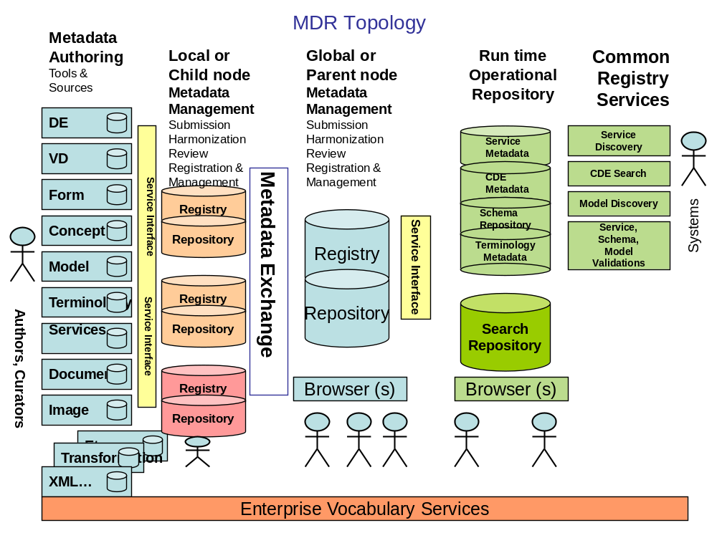
Figure 7: By adopting registries built on the ISO/IEC 11179 Metadata Registry standard, the infrastructure will support federated queries to allow users to find potential semantic metadata anywhere in the community, inside or outside caGrid, facilitating sharing across government, industry and national boundaries.

Initiative 2 - The semantic infrastructure must support clinical domains governed by regulation and complex business relationships, and also research where agility is paramount. Experience has shown that caBIG’s model-driven, labor intensive semantics does not comfortably support rapid evolution of services that is characteristic of the research domain. Also the labor intensive, UML model-centric style of metadata creation will not scale to the NHIN, nor adapt easily to non-object oriented programming. It may be possible to automatically extract the contextual information about services from line-of-business artifacts, for example from ECCF artifacts or from B2B service definitions, and to generate data elements that describe the context of individual services and service interactions as metadata. This initiative will explore approaches to automated metadata extraction from line of business artifacts and will implement a proof of concept extraction capability, concentrating on ECCF artifacts. If successful, this approach could reduce manual effort to define the semantics of services while also making it easier to semantically define services consistently across multiple development platforms (.NET, Semantic Web, OO, etc.) This high-risk/high reward applied research activity will be limited to analysis and small scale feasibility testing.

Initiative 3 - Rules management components are largely a new resource area. A Rules Management resource is required to support behavioral semantics. Much of clinical care information exchange is mediated by service contracts reflecting HL7 conventions. Contracts are vital to environments where regulatory, privacy, and business considerations must be enforced. The contract specifications (see Figure 3) need to be persisted and some provision made for run time support of contracts (see Figure 4). A Rules Management resource would enable definition and storage of the enterprise level business activities and role relationships between actors; the roles, behaviors and conformance points and other factors required to persist contract definitions and to support run time execution. This initiative will define the rules management architecture and design and implement an initial Rules Management resource. This will involve resolving numerous open issues. For example there are alternative approaches to rule representation (SBVR, SWRL, etc. The initiative will analyze them and match them against available use cases. Also some form of concept resolution is required for Rules Management, but determination of the semantic equivalence of concept expressions means that information model primitives to be matched share an underlying ontology, or have access to a cross-ontology mapping (a driver for initiative 5 below). This would limit ability to recognize equivalent concepts expressions to contexts in which the business case for creation of expensive maps is justified or in which regulation requires all to use a single terminology. However there may be opportunities to use machine learning to reduce the burden of manual ontology mapping, or to use federated ontologies to largely escape the need for maps. This initiative will include testing and analysis of the alternative approached to making Concept Resolution more semantically capable and less labor intensive.

Initiative 4 - Electronic medical records and many other commonly used biomedical artifacts are documents. Even when a subset of the information contained in these documents is extracted for storage in databases, the bulk of the information in the documents themselves has been unavailable. Technology to deal with the documents themselves has been lacking. Slowly the Semantic Web is beginning to make inroads. More robust triple store technology and ontology resources are beginning to become widely used. On the expectation that W3C Semantic Web SOA resources dealing with biomedical documents will play a role in the NHIN and perhaps in the EMR and personal health record, this initiative will focus on introduction of Semantic Web technologies to caGrid. Under this initiative the caBIG® cross-cutting workspaces will play a major role, defining and overseeing activities to integrate W3C SOA with the caGrid®.
- Ontologically-aware query capabilities on caGrid®.
- Partnerships with NCRI, cancerGrid and other Grids to extablish some form of Grid to Grid semantic interoperation.
- Expanded out reach to W3C and related standards development organizations .
- Creation and adoption of ontologies for use in life science and clinical SOAs on the Semantic Net.

Initiative 5 - Currently we are well positioned to support distributed terminology services and compliance with the HL7 CTS2 terminology specification. The LexEVS server is compliant with a subset of the CTS2 specification. Although the CTS2 standard itself is not yet formally promulgated and harmonization with the OMG MIF is not complete, as a practical matter terminology management requirements are well understood. Enhancement of the LexGrid terminology model and LexEVS server architecture to comprehensively support CTS2 specifications would be part of this initiative. Development of an initial, miminal set of CTS2 compliant authoring applications (for value sets, maps and extensions) would be included.
Work under this initiative would include:
- Enhanced operational support of federated terminology nodes on caGrid® and on other connected grids (NCRI’s LexEVS instance for example).
- Operational support for creation and use of value sets, maps and terminology extensions and other CTS II capabilities.
- Collaborative ontology development and ontology federation through use of OBO-compliant means.

Initiative 6 - The increasing adoption of EVS terminologies and NCI metadata by federal agencies, as well as by commercial, clinical and international organizations, will require increased investments in terminology production, curation, licensing and services as well increased metadata curation and support.
- Increasingly rigorous processes for terminology creation, curation and QA to meet tighter regulatory, clinical and other requirements.
- Expanded work on terminology mapping, harmonization and federation to support widening use and integration with broader biomedical and health communities and standards.
- Strengthening the ontology components of EVS terminologies to support stronger semantics for other caBIG® components and for direct users of EVS terminologies.
- Creating and extending high-performance end-user interfaces suitable for broad use of EVS terminologies by researchers, clinicians, patients, administrators, and others.
- Expanded metadata curation support resources including training on new tools and techniques emerging from Initiative 1 and possibly 2.

Initiative 7 - This initiative is contingent on adoption by caBIG/CBIIT of a more than one architectural style. It focuses on assessing the ability of the resources developed in Initiatives 1, 3 and 5 to be aggregated in such a way as to provide semantic unification of artifacts from different architectural styles.

The semantic infrastructure must support clinical domains governed by regulation and complex business relationships, and also research where agility is paramount. Experience has shown that caBIG’s model-driven, labor intensive semantics does not comfortably support the research domain, hence the attempt to develop semantics from line of business artifacts (See Initiative 2). However support of both clinical and research domains probably will require changes to caBIG/CBIIT architectural model external to the semantics infrastructure. The top-down “derivative” architectural model that works reasonable well for the clinical space is a poor fit for the research domain. caBIG/CBIIT architects have begun to discuss use of bottom-up “compositional” architecture as an alternative that may be better suited to the needs of the research domain. See Table 2 for a summary of the properties of derivative and compositional architecture approaches.

Assessment and adoption of the compositional architecture approach as a solution to research domain needs is not part of this concept of operations. If, however, two architectural approaches were adopted by caBIG/CBIIT, the semantic infrastructure would have to support both.

The ii4sm architects have envisioned the logical components of the semantic infrastructure shown in Figure 2, 4 and 5 organized into a “semantic backbone” composing the three sets of interdependent semantic services as shown in Figure 8. ii4sm believes that a semantic backbone comprising both types of shared elements (from derivational and compositional approach) can be used to resolve the semantics of shared information from both sources. Figure 8 is a very high level representation that includes several components that are not fully architected, however it seems clear that in addition to the work done in Initiative 1, 3 and 5 (which would realize the resources called Information Management, Rules Management and Terminology Management respectively) additional integration would be needed to enable the components to operate as implied in Figure 8.

This Initiative will encompass definition and realization and testing of the interactions among the model, terminology and rules components. These tests would be designed to assess the backbone’s ability to correctly represent semantics of services designed top down (derivative) and bottom up (compositional) -- assuming both styles would be required to support the clinical and research domain’s operations. (Assessment of the ability of the compositional approach to support the need of the research domain for rapid evolution is not part of this proposal. That is assumed to be an initiative undertaken by the life sciences).

Table 2: High level characteristics of derivative and compositional architecture
(courtesy of A Honey & J Landgrebe)
Architecture type
Derivational
(“specialization by restriction”)
Compositional
(“specialization by extension”)
Modelling direction
Top-Down: from single, comprehensive, business level reference model to small, purpose-oriented models (“grammar and content are represented in single model”)
Bottom-up: from information model primitives to domain composites (“separation of grammar and content primitives so that each can be manipulated separately”)
Shared elements
Reference information model, derived domain information models, localised information models, data types
Vocabulary; rules
Domain agnostic reference model, data types
Open (in the sense of easily expansible) library of primitives
Vocabulary; rules
Type of reference model
Domain specific, minimal syntax and very rich semantics at the “shared” level (reference model contains both grammar and content)
Domain-independent, rich syntax and minimal semantics at shared reference “common model” level (“mostly grammar in the reference model”)
Specialization/Localisation technique
Restriction: via property deletions in specialised classes as well as property additions and constraints on attributes
Extension: No attribute deletions, use OO-type grammar to manage property addition and OO-constraints to create specialised classes
Primary interoperability paradigm
Message exchange/service collaboration based on identical information transport objects carrying infrastructure in payload
Message exchange/service collaboration based on processing of information transport objects derived from shared infrastructure, minimal payload
MOF/MDA/XMI and SBVR compatibility
No (or limited)
Yes
Examples
HL7 V3 MIF
openEHR, (CCTS)
Properties
Architecture

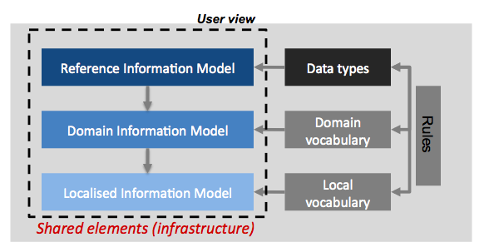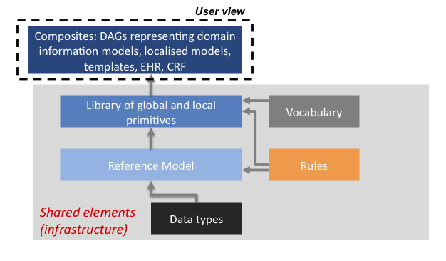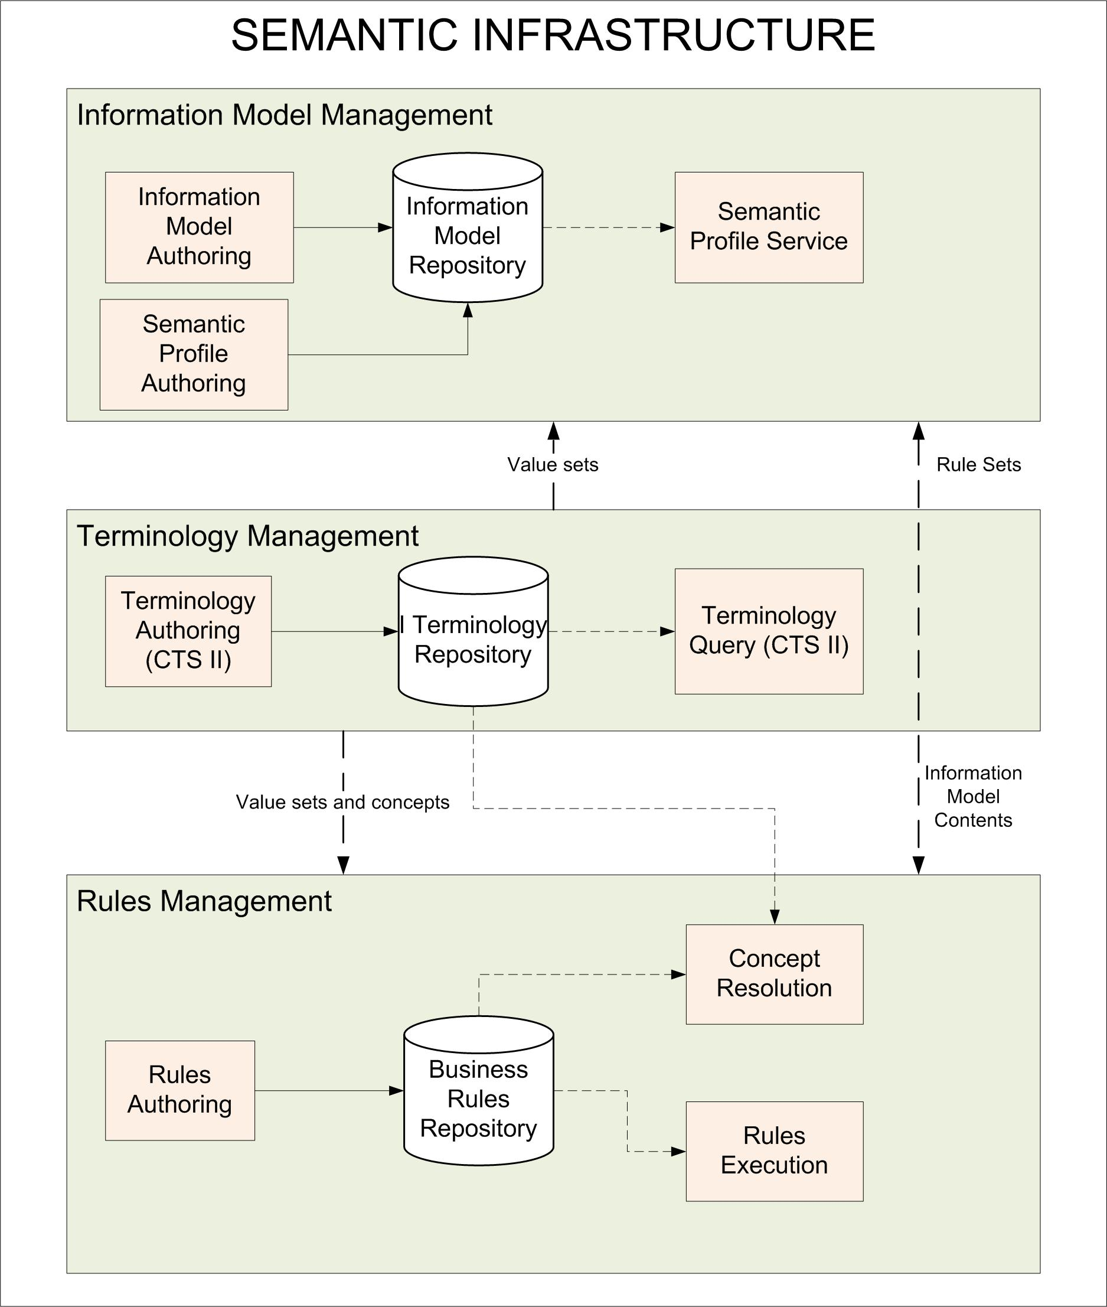
Figure 8: Grouping of Semantics Services. Some resources not explicitly represented (e.g. ISO 11179 Repository and ISO 21090 Service). Courtesy of A Honey & J Landgrebe

Stakeholders

The caBIG® Semantic Infrastructure will operate within a broad stakeholder community consisting of representatives of all of the professions and services involved in medical research and clinical care.

Primary stakeholders of the caBIG® Semantic Infrastructure include caBIG® and BIG Health, federal and international semantic content development partners (notably FDA and CDISC), developers and users of the caEMR, and software vendors that rely on the ECCF artifacts to develop offerings compatible with caBIG® specifications. It is anticipated that many of these stakeholders will not leverage our implementations, but rather will provide independently developed implementation that will interoperate with caBIG or caGrid.

Some stakeholders are direct or indirect end users of the terminologies (EVS) and the registered metadata (MDRs). Direct end users of the semantic infrastructure are those who would leverage the terminology or metadata programmatically to build metadata driven software, for designing data services or for electronic data collection applications from the registered metadata. Others might use the user interfaces to look up the meaning of terminology when writing research papers, annotating instance data, or annotating metamodels for registration to be used in future software development, discovery and data/information mining services, data items found on forms, in applications or data repositories developed by the community.

Indirect users are those using the software applications that have been developed on top of the semantic infrastructure such as an application to discover related data or analytic services, an online data collection application in which the reference documentation registered alongside the metadata item and made available by the application as on-line “Help” such as instructions or standard documentation. Other indirect users may use software written to leverage the semantic infrastructure to discover new or hidden relationships in the data.

The primary direct and indirect end users include:
- Software and Application designers and architects
- Software and Application engineers and developers
- Scientific and medical researchers
- Medical research protocol designers
- Clinical and scientific research data managers
- Clinicians
- Patients
- Medical research study participants

The broader stakeholders who will benefit from structured metadata driven software engineering and controlled terminology include:

- The caBIG® community
- NHIN, EMR and caEMR projects and related commercial COTS vendors
- Clinical care providers
- Patients and patient care advocates
- Insurance and payer communities
- Health care innovators
- Health care related companies and their investors
- Information technology communities
- Standards Development Organizations
  - CDISC, ISO, HL7
- Personal health organizations and proponents
- Health care and biomedical research related industry, such as pharmaceutical and medical equipment manufacturers
- Government and regulatory bodies
  - FDA, CDC, ONC
- International bodies
  - NCRI, CancerGrid

Alternatives/Constraints/Contracting Approach

General Approach:
The general annual approach to be taken by the caBIG® Semantic Infrastructure is as follows:

- Evaluate results of previous year's projects with emphasis on addressing shortcomings, reducing the barriers to adoption, adaptation and deployment of the semantic infrastructure
- Align priorities, scope, schedule with caBIG® enterprise projects and priorities via C-Team guidance.
- Engage Clinical Trials and Life Science Governance Groups regarding semantics needs and project priorities and participation
- Identify existing projects to be continued/halted and new projects to be started in the coming year.
- Design projects relying on E-CAT for conformance and compliance guidance before and during project execution following ECCF process.
- Rely upon caBIG® cross cutting work group review for compliance certification
- Maintain semantic integrity within clinical and research domains and extend semantic support to include behavioral semantics and semantic based reasoning as needed to support enterprise priorities.
- Engage with standards development organizations to influence and use critical existing and emerging health informatics, IT metadata and services standards

Contracting Approach
Project resources: Project resources are projected to derive from the base FY09 CBIIT budget for Enterprise CORE, and from ARRA funds associated with expansion of the cancer research program, the electronic medical record and national health information network. In most cases, appropriated funds will be expended to support operations and maintenance and evolution of existing products and services. Existing vendor contracts will generally be renewed and extended to leverage the accumulated expertise in existing teams and avoid project disruption. ARRA funding will be used to support new starts. Due to the time constraints associated with ARRA funding resources to accomplish “green field” projects will be acquired as much as possible using the NCI omnibus procurement vehicle, NIH BPAs and other vehicles that do not require de novo contracts under conventional contracting mechanisms.

Risks:
- Poor 3rd Party Adoption Risks: The caBIG approach to semantics would achieve highest success if adoption increases over time. This includes 3rd party development of implementations conforming to the semantics approach, as well as using the caBIG implementations for storing data elements, data models, controlled vocabulary, etc. Use of the ECCF to produce implementation independent specifications describing our semantics should help to reduce the risk of 3rd poor party implementation. Gathering and responding to user needs during all phases of the ECCF process should help to assure that semantics resources are suited to community needs. Semanitcs services and repositories developed and maintained by CBIIT which form "reference implementation", and provision for a lot of training and outreach to the community, should help reduce the risk of the community failing to use the semantics resources.
- ARRA Driven Risks: The emphasis on EHR adoption and use and related national initiatives has increased the breadth of support the caBIG® Semantic Infrastructure must address. Related changes such as introduction of the ECCF process offer adaptive advantages in the context of the increased scope, however the combination of evolving organizational practices and greatly expanded scope increases both technical and management risk. The best mitigation for this risk is to pursue development initiatives in an iterative fashion and to continually assess the progress and programmatic value of ongoing initiatives so that initiatives can be adjusted. The Semantic Infrastructure and Operations group will rely heavily on the C-Team/E-CAT and other caBIG Governance Groups in pursuing this risk management strategy.
- ECCF/CAT Risks: This is a new process that is not yet well defined nor understood by those who are being asked to employ it. The organizational changes required to understand and employ any new process takes time, more so with a complex, novel process that has not been used elsewhere previously and which affects every development initiative enterprise-wide. There are no existing supporting tools or standard documentation. It is unclear what the artifacts should contain, how they are used, or what the LOE will be to create and review them. There is a risk that the process itself will produce more documentation and artifacts than current government staff can absorb and that decision making will get bottlenecked, forcing delays or even decisions made without enough information. Management of this risk requires the ECCF to be operationalized as soon as possible. Training on what following the ECCF means, operationally, for the Semantic Infrastructure team must be developed on an expedited basis.
- Coordination Risks: Even while the Infrastructure Team is pursuing its initiatives, the domain workspaces will be creating solutions that will be expected to interoperate/integrate/conform with the semantic infrastructure. The possibilities for SNAFUs are endless. Absent an existing formal mechanism for coordination, management of this risk requires that Semantics Team managers become involved in the Domain Governance Groups as well as the Composite Architecture Teams, and that they establish clear and continual exchange of information about the relationships of initiatives and effects of decisions. Prompt access to the C-Team for mediation and decisions about priorities and direction will also be needed.

This is an important aspect of Semantics, caDSR and Grid that is very important to disambiguate (and separate) in the future semantic infrastructure). Right now, we COMPEL developers to do A LOT more in caDSR that is strictly necessary for semantics, but it IS needed for “seamless integration thru SQL queries on caGrid). Thus, the caDSR stands now as the nexus between the semantic world and the syntactic world. Those worlds are explicitly separated under ECCF, but their conflation is in our current semantics is one of the main causes of the two issues noted here).

